**Solution Mapping Platform**

**Drafting recommendations towards opening the platform**

**to indigenous and farmer’s communities**

**(February – March 2023)**

**Background on the Acc Lab Guatemala approach:**

A series of comments and recommendations about the Acc Labs website are presented in the ope to enhance the user experience to end users of Climate Change Challenge, considering most of them face vulnerable conditions.

The purpose of these comments is to provide input to Global Team (JB), that will help make the user’s experience on the site easier, more efficient, and friendly. Another important reason for aiming into options more friendly to indigenous communities, is that the target group of farmes are non-Spanish native speakers, having Cakchiquel as their mother tongue language and Spanish as a second language.

We’ve noticed some women aren’t fully literate, and therefore, we’re seeking to include as much people as possible to enjoy the power of the Solutions Mapping Platform and widen-up their knowledge on challenges they understand very well by adapting every day to water scarcity as impact of Climate Change.

Likewise, by making users have a better experience within the page, we would achieve:

1. The work of the Acc Labs could reach more people and generate an even greater impact.
2. The platform is more inclusive with people who do not have a high command of the management of digital tools and / or the English language.
3. (Desirable) More people can share their solutions, doubts, and comments regarding other ideas they can find on the platform.

**Drafting observations and recommendations**

1. The access link should be shorter and easier for people to type. This would make it easier to share the page with more people.

1. The default language of the page is English, so people who do not speak English may not know where to go. The page could be made to determine the language in which it should start, depending on the IP of the computer or phone used to log in.
2. The language options could be clearer, saying the complete language to make it easier to switch from one language to another. Currently, there are only abbreviations, so it is recommended that you can put the complete words, such as: "español" and "english".

1. Even when one chooses the Spanish option, most of the page remains in English. Ideally, when selecting a language, the entire page should be automatically translated so that people can interact with all the available options.

Spanish selected

English

1. Most solutions have been entered in English and are not automatically translated when the language is changed, so we considered it valuable that this would be an option for non-English speakers to learn about more solutions.

1. The visualization of certain parts overlaps due to the graphic design of the page, so it is not possible to read all the options.

1. When entering a new solution in a blank notebook, it should be further specified that there is a section that is mandatory to fill out in order to be submitted. This section is presented below:

1. When you want to send a solution to be reviewed before publication, the only language offered is French and it is not fully readable.

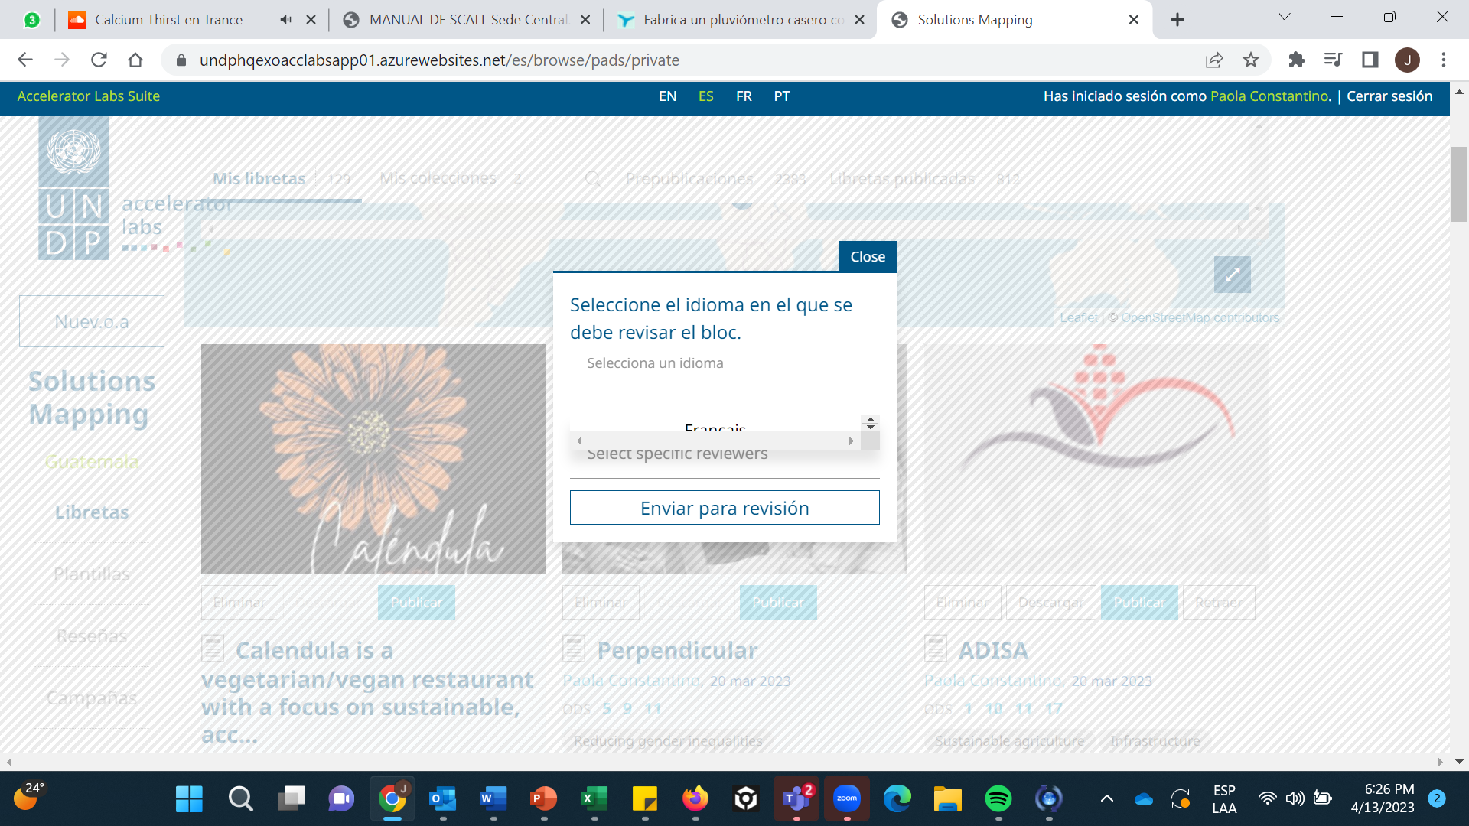

**Thanks Jeremy 😊**